# OVER VIEW OF OPERATING SYSTEM

**What is an Operating System**?

A program that acts as an intermediary between a user of a computer and the computer hardware

Operating system goals:

* Execute user programs and make solving user problems easier
* Make the computer system convenient to use
* Use the computer hardware in an efficient manner

# Computer System Structure

Computer system can be divided into four components

* Hardware – provides basic computing resources

CPU, memory, I/O devices

* Operating system

Controls and coordinates use of hardware among various applications and users

* Application programs – define the ways in which the system resources are used to solve the computing problems of the users

Word processors, compilers, web browsers, database systems, video games

* Users

People, machines, other computers

## Four Components of a Computer System

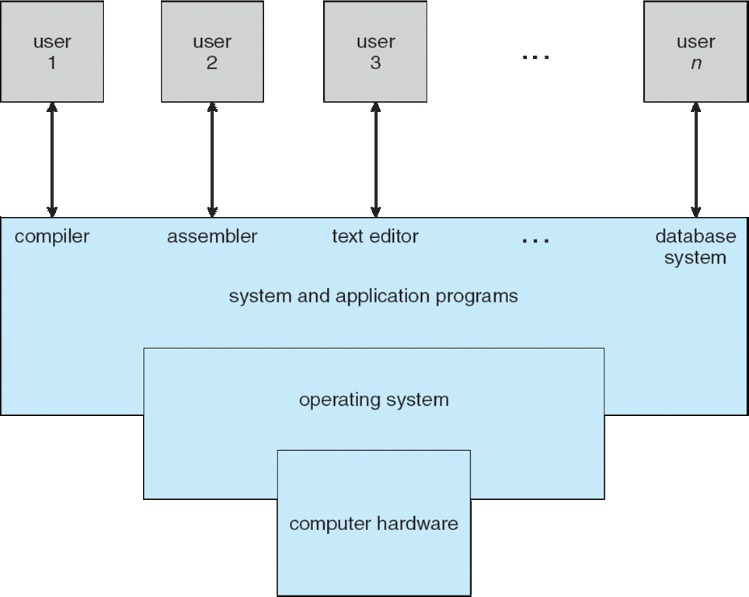

**Operating System Definition**

* OS is a **resource allocator**
* Manages all resources
* Decides between conflicting requests for efficient and fair resource use
* OS is a **control program**
* Controls execution of programs to prevent errors and improper use of the computer
* No universally accepted definition
* Everything a vendor ships when you order an operating system” is good approximation

But varies wildly

* “The one program running at all times on the computer” is the **kernel.** Everything else is either a system program (ships with the operating system) or an application program

**Computer Startup**

* **bootstrap program** is loaded at power-up or reboot
* Typically stored in ROM or EPROM, generally known as **firmware**
* Initializes all aspects of system
* Loads operating system kernel and starts execution

**Computer System Organization**

* Computer-system operation
* One or more CPUs, device controllers connect through common bus providing access to shared memory
* Concurrent execution of CPUs and devices competing for memory cycles

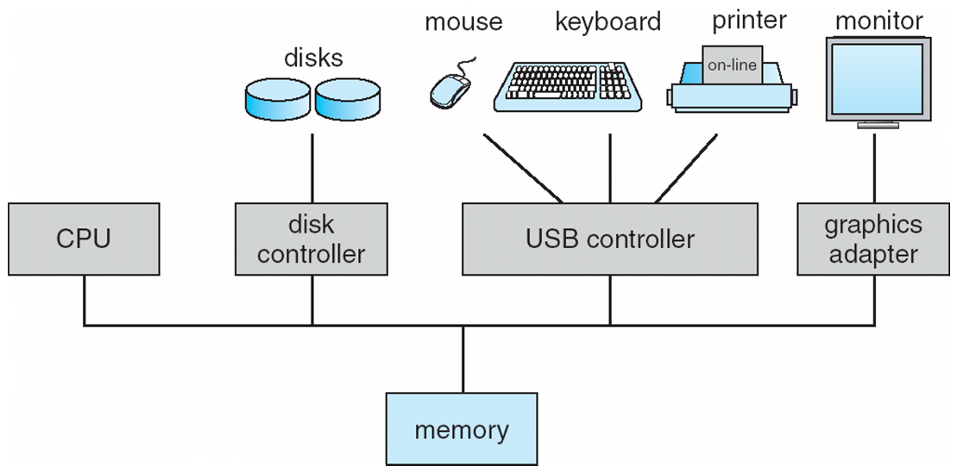

**Computer-System Operation**

* I/O devices and the CPU can execute concurrently
* Each device controller is in charge of a particular device type
* Each device controller has a local buffer
* CPU moves data from/to main memory to/from local buffers
* I/O is from the device to local buffer of controller
* Device controller informs CPU that it has finished its operation by causing An *interrupt*

**Common Functions of Interrupts**

* Interrupt transfers control to the interrupt service routine generally, through the **interrupt****vector**, which contains the addresses of all the service routines
* Interrupt architecture must save the address of the interrupted instruction
* Incoming interrupts are *disabled* while another interrupt is being processed to prevent a *lost interrupt*
* nA *trap* is a software-generated interrupt caused either by an error or a user request
* An operating system is **interrupt driven**

**Interrupt Handling**

* The operating system preserves the state of the CPU by storing registers and the program counter
* Determines which type of interrupt has occurred:
* **polling**
* **vectored** interrupt system
* Separate segments of code determine what action should be taken for each type of interrupt

**Interrupt Timeline**

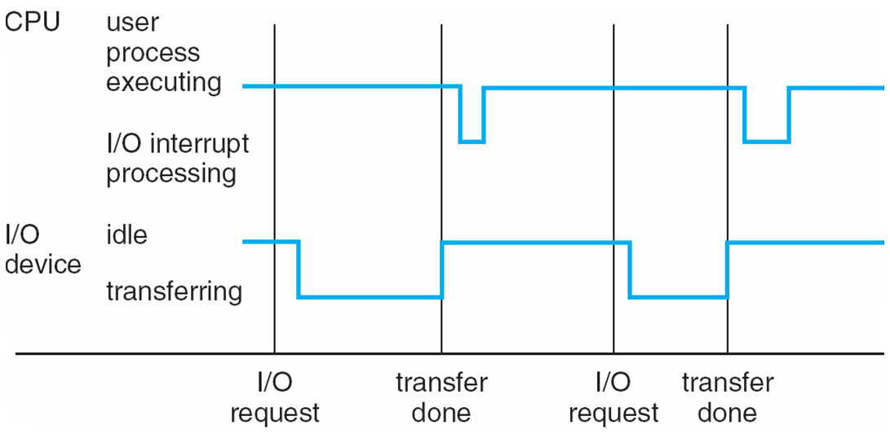

**I/O Structure**

* After I/O starts, control returns to user program only upon I/O completion
* Wait instruction idles the CPU until the next interrupt
* Wait loop (contention for memory access)
* At most one I/O request is outstanding at a time, no simultaneous I/O processing
* After I/O starts, control returns to user program without waiting for I/O completion
* **System call** – request to the operating system to allow user to wait for I/O completion
* **Device-status table** contains entry for each I/O device indicating its type, address, and **state**
* Operating system indexes into I/O device table to determine device status and to modify table entry to include interrupt

**Direct Memory Access Structure**

* Used for high-speed I/O devices able to transmit information at close to memory speeds
* Device controller transfers blocks of data from buffer storage directly to main memory without CPU intervention
* Only one interrupt is generated per block, rather than the one interrupt per byte

**Storage Structure**

* Main memory – only large storage media that the CPU can access directly
* Secondary storage – extension of main memory that provides large nonvolatile storage capacity
* Magnetic disks – rigid metal or glass platters covered with magnetic recording material
* Disk surface is logically divided into **tracks**, which are subdivided into **sectors**
* The **disk controller** determines the logical interaction between the device and the computer

**Storage Hierarchy**

* Storage systems organized in hierarchy
* Speed
* Cost
* Volatility

**Caching** – copying information into faster storage system; main memory can be viewed as a last *cache* for secondary storage

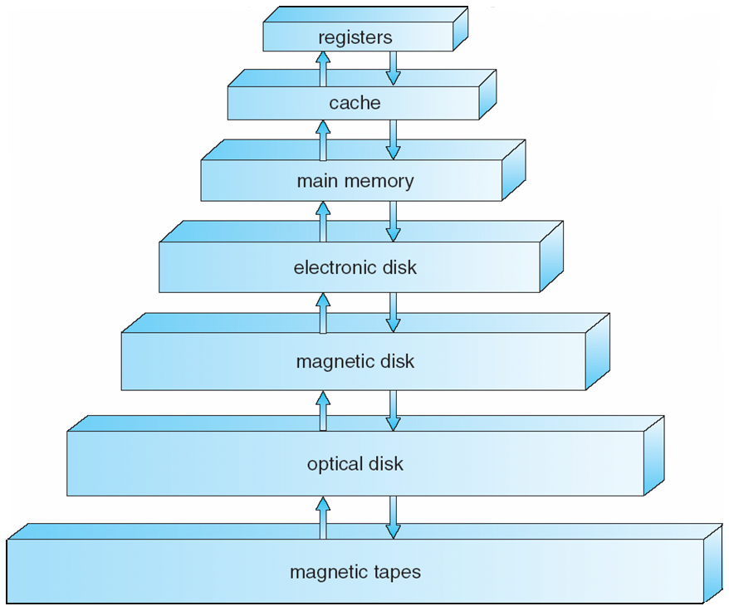

**Caching**

* Important principle, performed at many levels in a computer (in hardware, operating system, software)
* Information in use copied from slower to faster storage temporarily
* Faster storage (cache) checked first to determine if information is there
* If it is, information used directly from the cache (fast)
* If not, data copied to cache and used there
* Cache smaller than storage being cached
* Cache management important design problem
* Cache size and replacement policy

## Computer-System Architecture

* Most systems use a single general-purpose processor (PDAs through mainframes)
* Most systems have special-purpose processors as well
* Multiprocessors systems growing in use and importance
* Also known as parallel systems, tightly-coupled systems

Advantages include

1.Increased throughput

2.Economy of scale

3.Increased reliability – graceful degradation or fault tolerance

Two types

1.Asymmetric Multiprocessing

2.Symmetric Multiprocessing

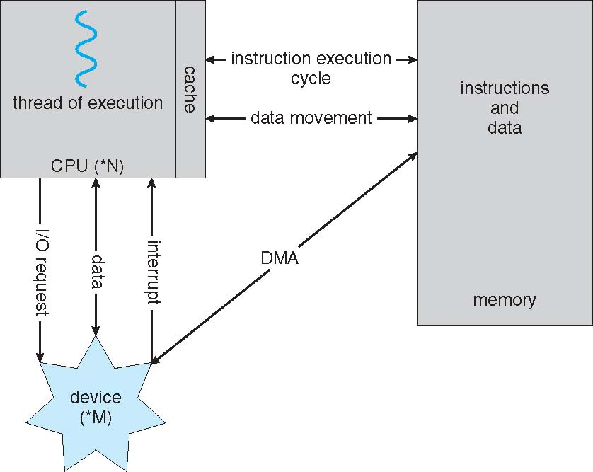

**How a Modern Computer Works**

**Symmetric Multiprocessing Architecture**

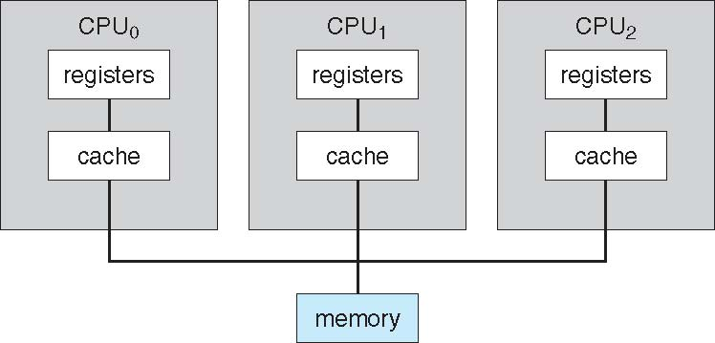

**A Dual-Core Design**

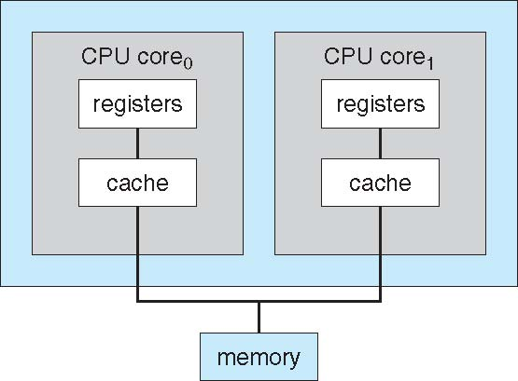

## Clustered Systems

* Like multiprocessor systems, but multiple systems working together
* Usually sharing storage via a storage-area network (SAN)
* Provides a high-availability service which survives failures

Asymmetric clustering has one machine in hot-standby mode

Symmetric clustering has multiple nodes running applications, monitoring each other

* Some clusters are for high-performance computing (HPC)

Applications must be written to use parallelization

**Operating System Structure**

* **Multiprogramming** needed for efficiency
* Single user cannot keep CPU and I/O devices busy at all times
* Multiprogramming organizes jobs (code and data) so CPU always has one to Execute
* A subset of total jobs in system is kept in memory
* One job selected and run via **job scheduling**
* When it has to wait (for I/O for example), OS switches to another job
* **Timesharing (multitasking)** is logical extension in which CPU switches jobs so frequently that users can interact with each job while it is running, creating **interactive** computing
* **Response time** should be < 1 second
* Each user has at least one program executing in memory **process**
* If several jobs ready to run at the same time **CPU scheduling**
* If processes don’t fit in memory, **swapping** moves them in and out to run

**Virtual memory** allows execution of processes not completely in memory

**Memory Layout for Multiprogrammed System**

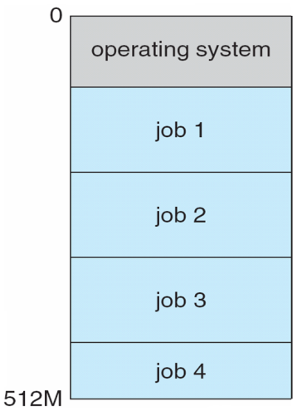

## Operating-System Operations

* Interrupt driven by hardware
* Software error or request creates **exception** or **trap**
* Division by zero, request for operating system service
* Other process problems include infinite loop, processes modifying each Other or the operating system
* **Dual-mode** operation allows OS to protect itself and other system components
* **User mode** and **kernel mode**
* **Mode bit** provided by hardware

Provides ability to distinguish when system is running user code or kernel code

Some instructions designated as **privileged**, only executable in kernel mode

System call changes mode to kernel, return from call resets it to user

**Transition from User to Kernel Mode**

* Timer to prevent infinite loop / process hogging resources
* Set interrupt after specific period
* Operating system decrements counter
* When counter zero generate an interrupt
* Set up before scheduling process to regain control or terminate program that exceeds allotted time

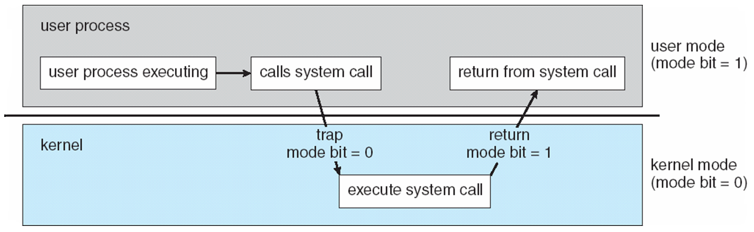

### OPERATING SYSTEM FUNCTIONS

**Process Management**

* A process is a program in execution. It is a unit of work within the system. Program is a *passive entity*, process is an *active entity*.
* Process needs resources to accomplish its task
* CPU, memory, I/O, files
* Initialization data
* Process termination requires reclaim of any reusable resources
* Single-threaded process has one **program counter** specifying location of next instruction to execute
* Process executes instructions sequentially, one at a time, until completion
* Multi-threaded process has one program counter per thread
* Typically system has many processes, some user, some operating system running concurrently on one or more CPUs
* Concurrency by multiplexing the CPUs among the processes / threads

**Process Management Activities**

* The operating system is responsible for the following activities in connection with process management:
* Creating and deleting both user and system processes
* Suspending and resuming processes
* Providing mechanisms for process synchronization
* Providing mechanisms for process communication
* Providing mechanisms for deadlock handling

**Memory Management**

* All data in memory before and after processing
* All instructions in memory in order to execute
* Memory management determines what is in memory when
* Optimizing CPU utilization and computer response to users
* **Memory management activities**
* Keeping track of which parts of memory are currently being used and by whom
* Deciding which processes (or parts thereof) and data to move into and out of memory
* Allocating and deallocating memory space as needed

**Storage Management**

* OS provides uniform, logical view of information storage
* Abstracts physical properties to logical storage unit - **file**
* Each medium is controlled by device (i.e., disk drive, tape drive)
* Varying properties include access speed, capacity, data-transfer rate, access method (sequential or random)
* File-System management
* Files usually organized into directories
* Access control on most systems to determine who can access what
* **OS activities include**
* Creating and deleting files and directories
* Primitives to manipulate files and dirs
* Mapping files onto secondary storage
* Backup files onto stable (non-volatile) storage media

**Mass-Storage Management**

* Usually disks used to store data that does not fit in main memory or data that must be kept for a “long” period of time
* Proper management is of central importance
* Entire speed of computer operation hinges on disk subsystem and its algorithms
* **MASS STORAGE activities**
* Free-space management
* Storage allocation
* Disk scheduling
* Some storage need not be fast
* Tertiary storage includes optical storage, magnetic tape
* Still must be managed
* Varies between WORM (write-once, read-many-times) and RW (read-write)

## Performance of Various Levels of Storage

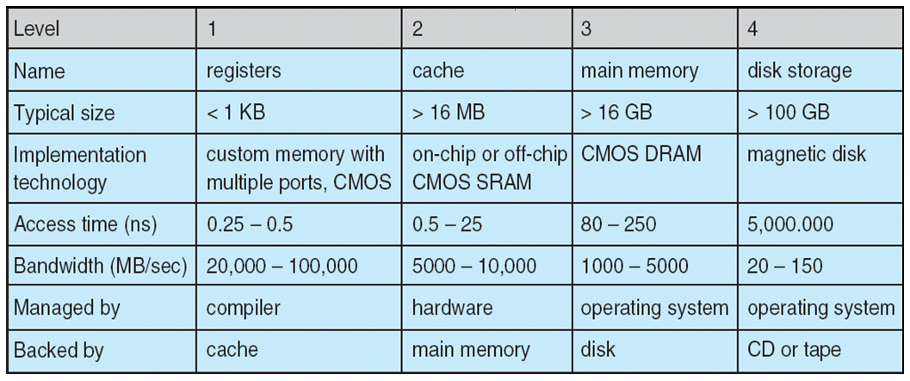

**Migration of Integer A from Disk to Register**

* 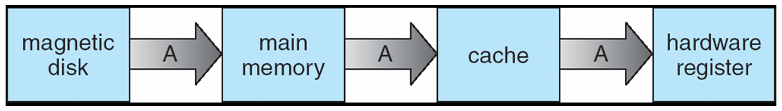Multitasking environments must be careful to use most recent value, no matter where it is stored in the storage hierarchy
* Multiprocessor environment must provide cache coherency in hardware such that all CPUs have the most recent value in their cache
* Distributed environment situation even more complex
* Several copies of a datum can exist

## I/O Subsystem

* One purpose of OS is to hide peculiarities of hardware devices from the user
* I/O subsystem responsible for
* Memory management of I/O including buffering (storing data temporarily while it is being transferred), caching (storing parts of data in faster storage for performance), spooling (the overlapping of output of one job with input of other jobs)
* General device-driver interface
* Drivers for specific hardware devices

#### Protection and Security

**Protection** – any mechanism for controlling access of processes or users to resources defined by the OS

**Security** – defense of the system against internal and external attacks

* Huge range, including denial-of-service, worms, viruses, identity theft, theft of service
* Systems generally first distinguish among users, to determine who can do what
* User identities (**user IDs**, security IDs) include name and associated number, one per user
* User ID then associated with all files, processes of that user to determine access control
* Group identifier (**group ID**) allows set of users to be defined and controls managed, then also associated with each process, file
* **Privilege escalation** allows user to change to effective ID with more rights

#### DISTRIBUTED SYSTEMS

**Computing Environments**

**Traditional computer**

* Blurring over time
* Office environment

PCs connected to a network, terminals attached to mainframe or minicomputers providing batch and timesharing

Now portals allowing networked and remote systems access to same resources

* Home networks

Used to be single system, then modems

Now firewalled, networked

* Client-Server Computing
* Dumb terminals supplanted by smart PCs
* Many systems now **servers**, responding to requests generated by **clients**

**Compute-server** provides an interface to client to request services (i.e. database)

**File-server** provides interface for clients to store and retrieve files

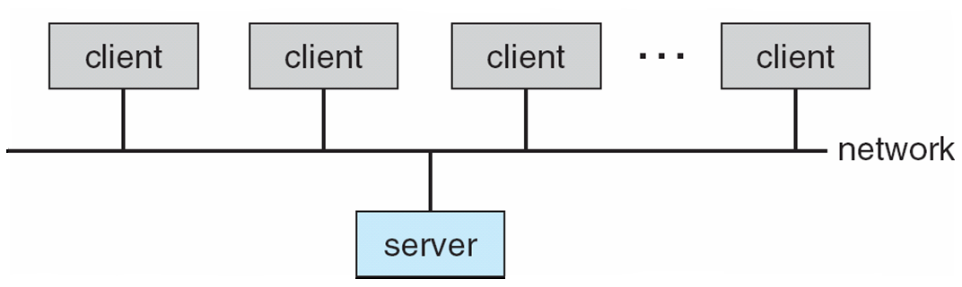

**Peer-to-Peer Computing**

* Another model of distributed system
* P2P does not distinguish clients and servers
* Instead all nodes are considered peers
* May each act as client, server or both
* Node must join P2P network

Registers its service with central lookup service on network, or

Broadcast request for service and respond to requests for service via **discovery protocol**

* Examples include *Napster* and *Gnutella*

## Web-Based Computing

* Web has become ubiquitous
* PCs most prevalent devices
* More devices becoming networked to allow web access
* New category of devices to manage web traffic among similar servers: **load balancers**
* Use of operating systems like Windows 95, client-side, have evolved into Linux and Windows XP, which can be clients and servers

**Open-Source Operating Systems**

* Operating systems made available in source-code format rather than just binary closed-source
* Counter to the copy protection and Digital Rights Management (DRM) movement
* Started by Free Software Foundation (FSF), which has “copyleft” GNU Public License (GPL)
* Examples include GNU/Linux, BSD UNIX (including core of Mac OS X), and Sun Solaris

## Operating System Services

* One set of operating-system services provides functions that are helpful to the user:
* User interface - Almost all operating systems have a user interface (UI)
* Varies between Command-Line (CLI), Graphics User Interface (GUI), Batch
* Program execution - The system must be able to load a program into memory and to run that program, end execution, either normally or abnormally (indicating error)
* I/O operations - A running program may require I/O, which may involve a file or an I/O device
* File-system manipulation - The file system is of particular interest. Obviously, programs need to read and write files and directories, create and delete them, search them, list file Information, permission management.

**A View of Operating System Services**

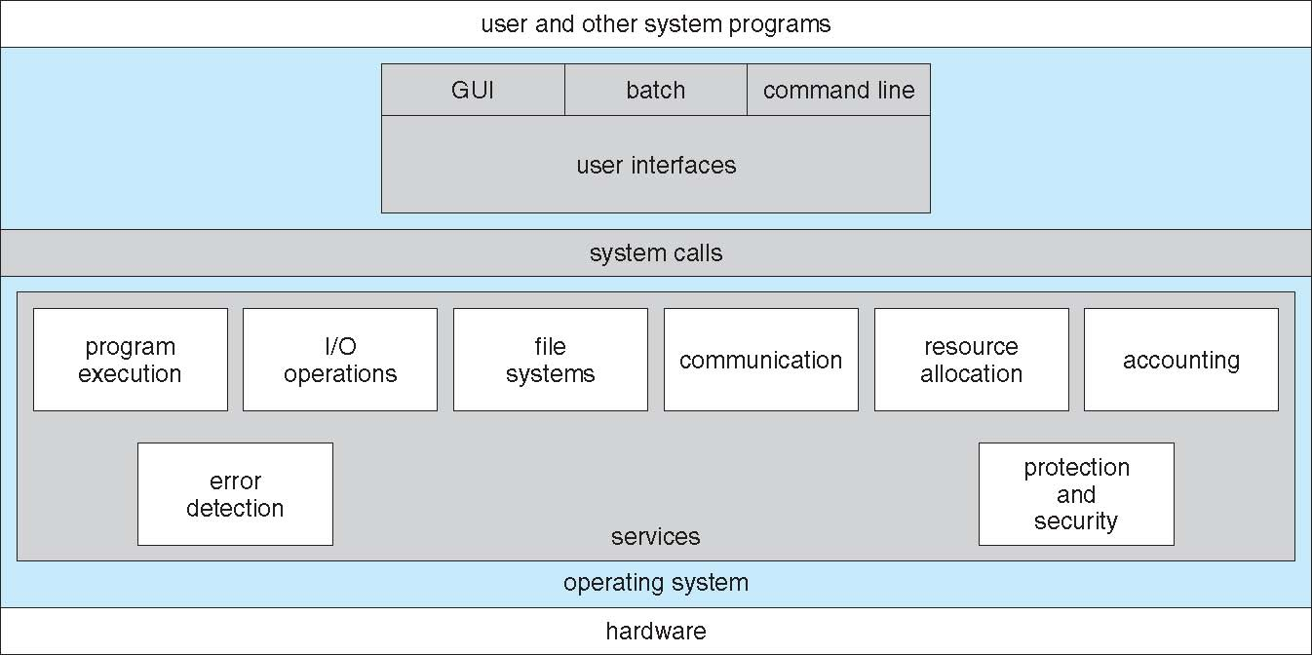

**Operating System Services**

* One set of operating-system services provides functions that are helpful to the user (Cont):
* lCommunications – Processes may exchange information, on the same computer or between computers over a network

Communications may be via shared memory or through message passing (packets moved by the OS)

* Error detection – OS needs to be constantly aware of possible errors

May occur in the CPU and memory hardware, in I/O devices, in user program

For each type of error, OS should take the appropriate action to ensure correct and consistent computing

Debugging facilities can greatly enhance the user’s and programmer’s abilities to efficiently use the system

* Another set of OS functions exists for ensuring the efficient operation of the system itself via resource sharing
* **Resource allocation -** When multiple users or multiple jobs running concurrently, resources must be allocated to each of them
* Many types of resources - Some (such as CPU cycles, main memory, and file storage) may have special allocation code, others (such as I/O devices) may have general request and release code
* **Accounting -** To keep track of which users use how much and what kinds of computer resources
* **Protection and security -** The owners of information stored in a multiuser or networked computer system may want to control use of that information, concurrent processes should not interfere with each other
* **Protection** involves ensuring that all access to system resources is controlled
* **Security** of the system from outsiders requires user authentication, extends to defending external I/O devices from invalid access attempts
* If a system is to be protected and secure, precautions must be instituted throughout it. A chain is only as strong as its weakest link.

**User Operating System Interface - CLI**

* Command Line Interface (CLI) or command interpreter allows direct command entry

Sometimes implemented in kernel, sometimes by systems program

Sometimes multiple flavors implemented – shells

Primarily fetches a command from user and executes it

* Sometimes commands built-in, sometimes just names of programs
* If the latter, adding new features doesn’t require shell modification

**User Operating System Interface - GUI**

* User-friendly desktop metaphor interface
* Usually mouse, keyboard, and monitor
* Icons represent files, programs, actions, etc
* Various mouse buttons over objects in the interface cause various actions (provide information, options, execute function, open directory (known as a folder)
* Invented at Xerox PARC
* Many systems now include both CLI and GUI interfaces
* Microsoft Windows is GUI with CLI “command” shell
* Apple Mac OS X as “Aqua” GUI interface with UNIX kernel underneath and shells available
* Solaris is CLI with optional GUI interfaces (Java Desktop, KDE)

**Bourne Shell Command Interpreter**

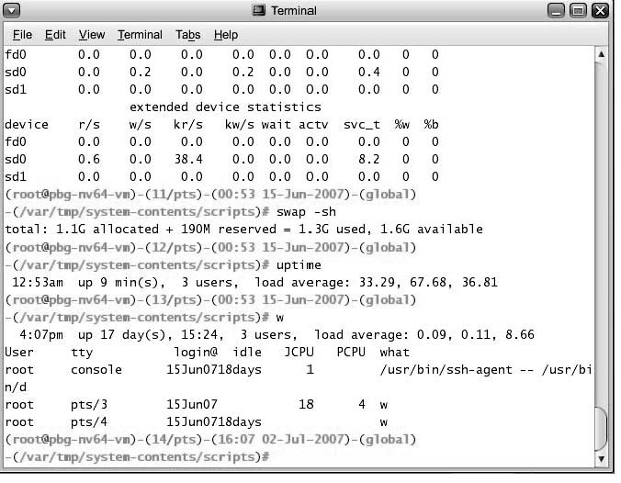

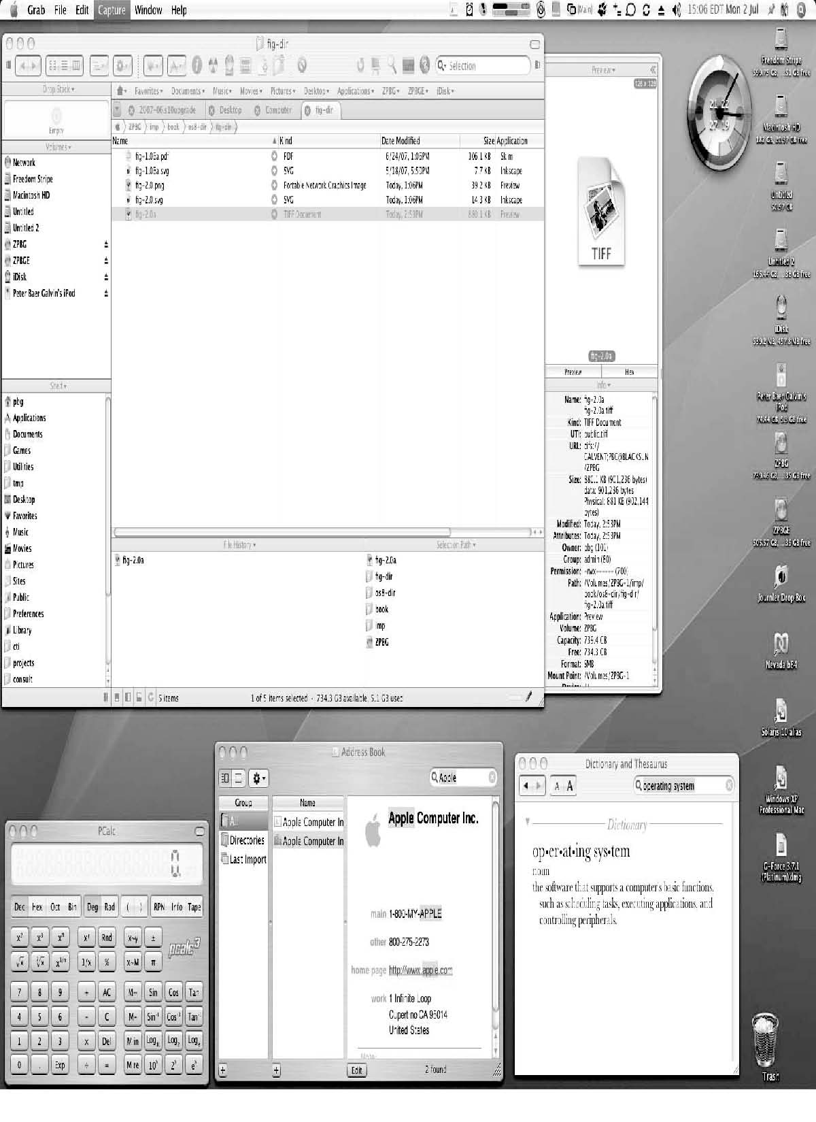**The Mac OS X GUI**

**System Calls**

* Programming interface to the services provided by the OS
* Typically written in a high-level language (C or C++)
* Mostly accessed by programs via a high-level Application Program Interface (API) rather than direct system call use
* nThree most common APIs are Win32 API for Windows, POSIX API for POSIX-based systems (including virtually all versions of UNIX, Linux, and Mac OS X), and Java API for the Java virtual machine (JVM)
* Why use APIs rather than system calls?
* (Note that the system-call names used throughout this text are generic)

**Example of System Calls**

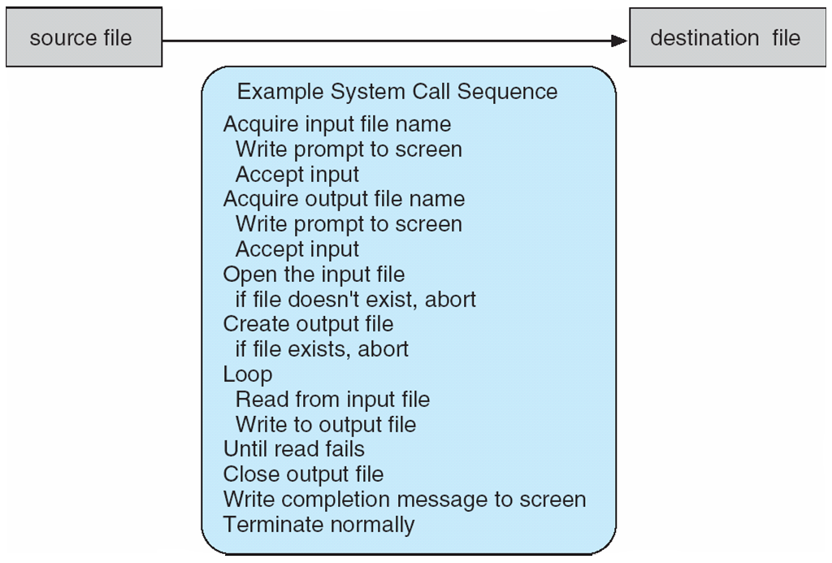

**Example of Standard API**

Consider the ReadFile() function in the

Win32 API—a function for reading from a file

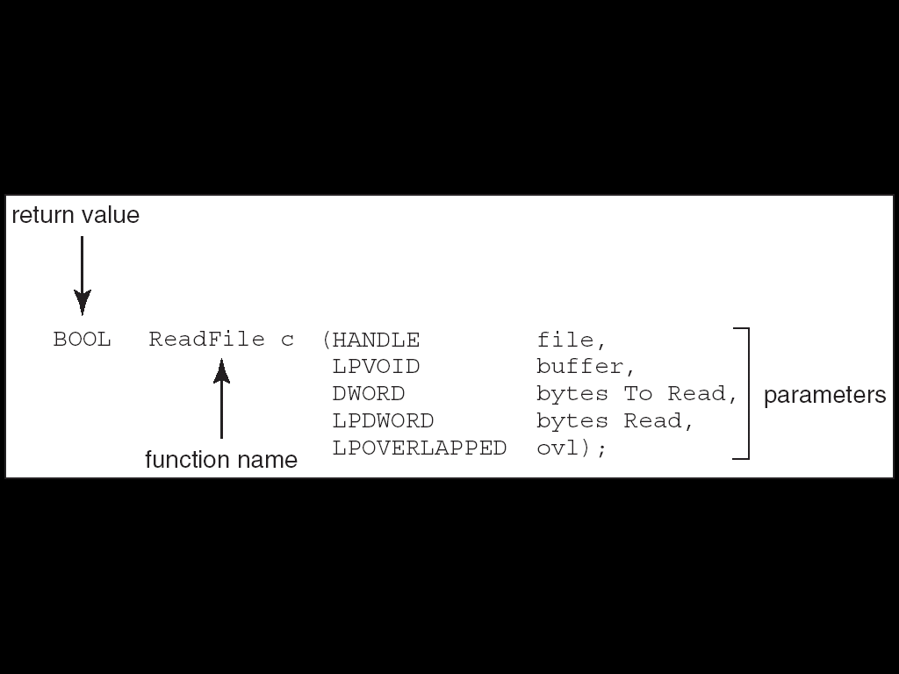

A description of the parameters passed to ReadFile()

* HANDLE file—the file to be read
* LPVOID buffer—a buffer where the data will be read into and written from
* DWORD bytesToRead—the number of bytes to be read into the buffer
* LPDWORD bytesRead—the number of bytes read during the last read
* LPOVERLAPPED ovl—indicates if overlapped I/O is being used

## System Call Implementation

* Typically, a number associated with each system call
* System-call interface maintains a table indexed according to these
* Numbers
* The system call interface invokes intended system call in OS kernel and returns status of the system call and any return values
* The caller need know nothing about how the system call is implemented
* Just needs to obey API and understand what OS will do as a result call
* Most details of OS interface hidden from programmer by API

Managed by run-time support library (set of functions built into libraries included with compiler)

**API – System Call – OS Relationship**

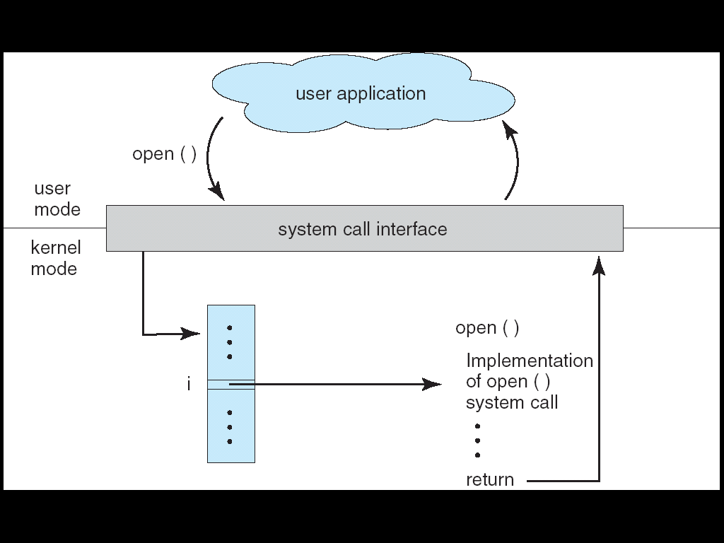

**Standard C Library Example**

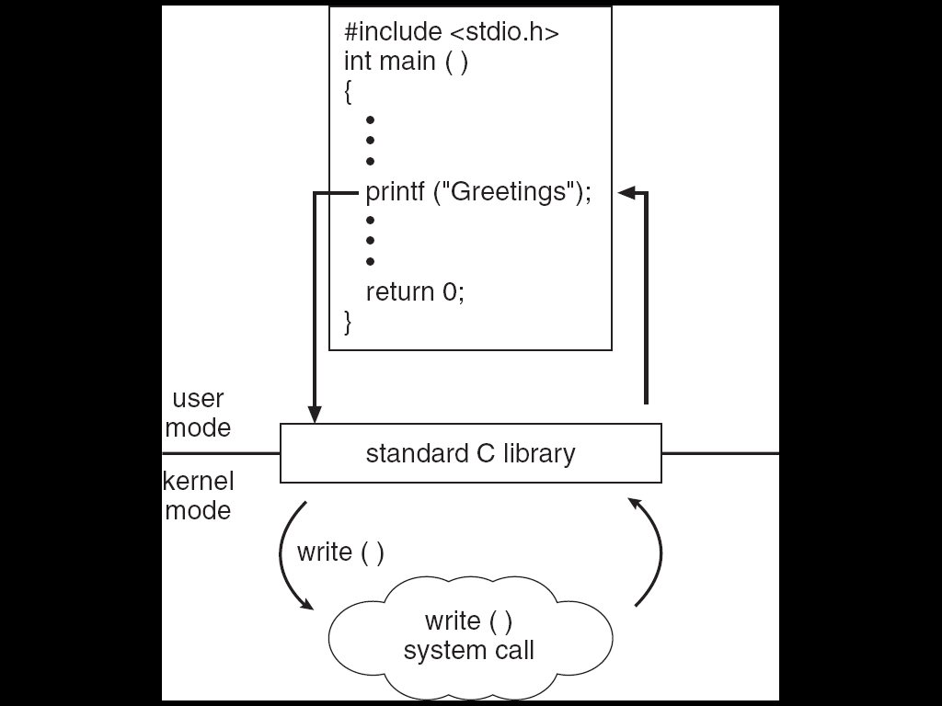

**System Call Parameter Passing**

* Often, more information is required than simply identity of desired system call
* Exact type and amount of information vary according to OS and call
* Three general methods used to pass parameters to the OS
* Simplest: pass the parameters in *registers*
  + In some cases, may be more parameters than registers
* Parameters stored in a *block,* or table, in memory, and address of block passed as a parameter in a register

This approach taken by Linux and Solaris

* Parameters placed, or *pushed,* onto the *stack* by the program and *popped* off the stack by the operating system
* Block and stack methods do not limit the number or length of parameters being passed

**Parameter Passing via Table**

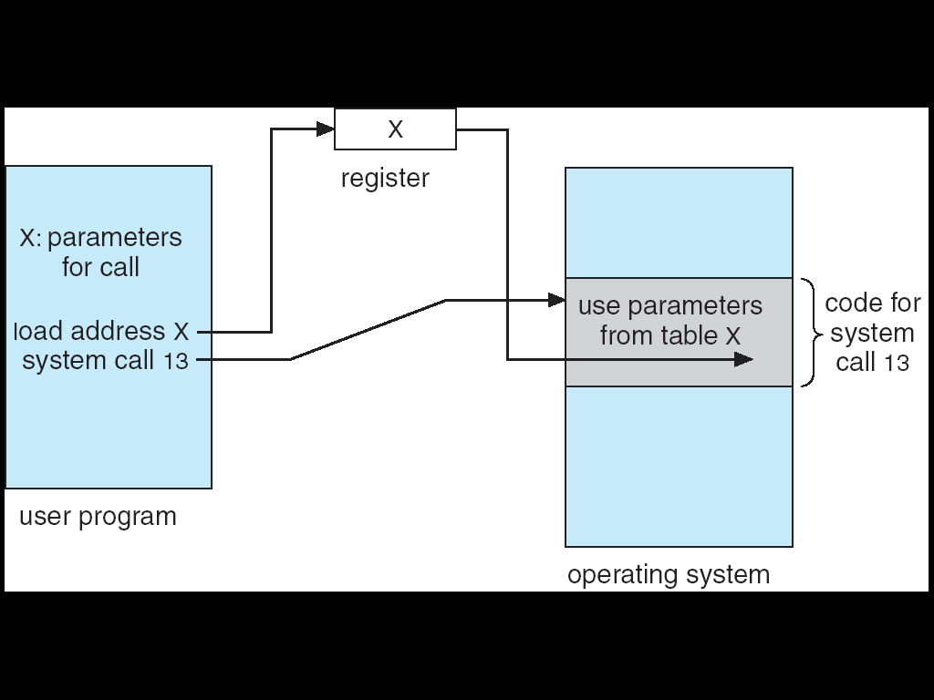

**Types of System Calls**

* Process control
* File management
* Device management
* Information maintenance
* Communications
* Protection

**Examples of Windows and Unix System Calls**

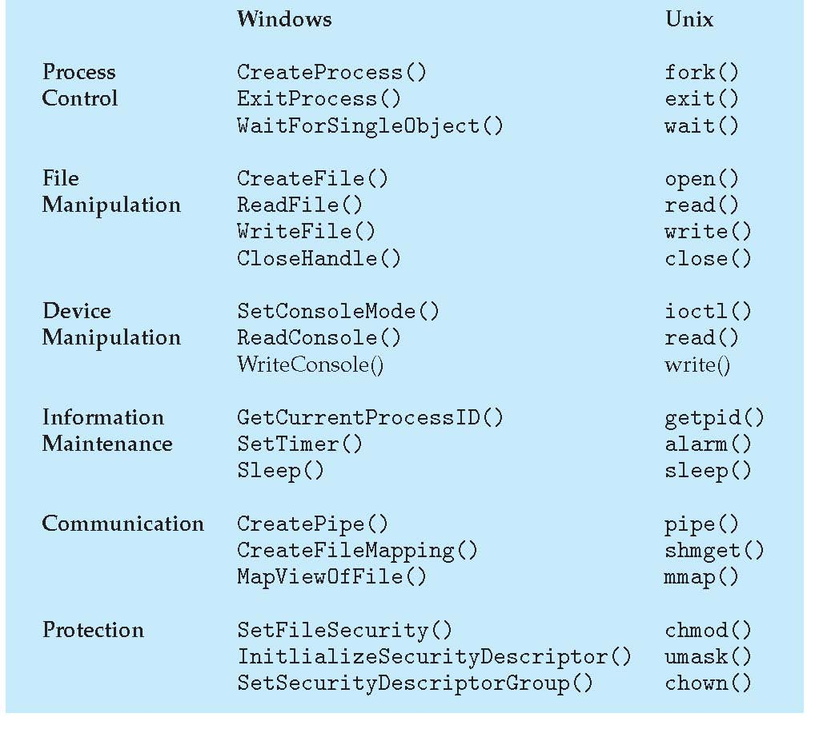

**MS-DOS execution**

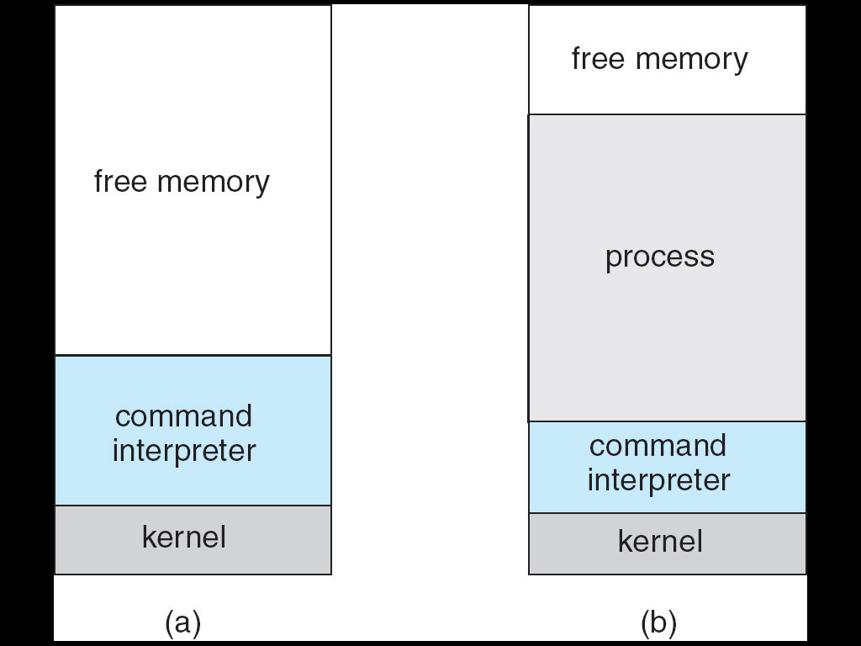

(a) At system startup (b) running a program

**FreeBSD Running Multiple Programs**

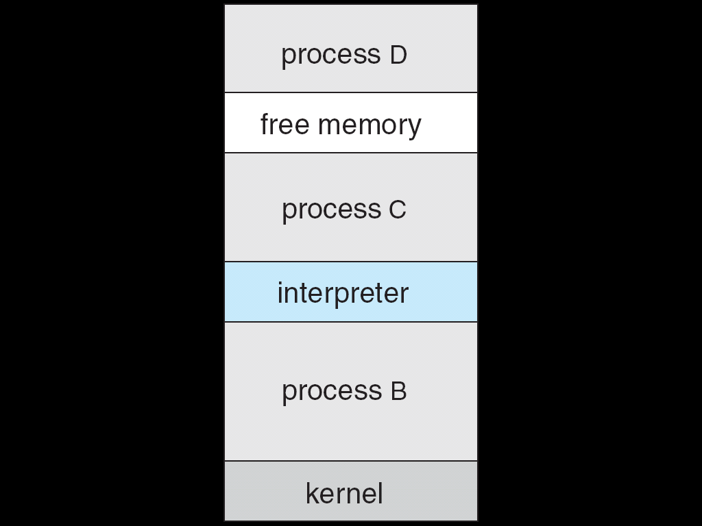

**System Programs**

System programs provide a convenient environment for program development and execution. The can be divided into:

* File manipulation
* Status information
* File modification
* Programming language support
* Program loading and execution
* Communications
* Application programs

Most users’ view of the operation system is defined by system programs, not the actual system calls

* Provide a convenient environment for program development and execution
* Some of them are simply user interfaces to system calls; others are considerably more complex
* File management - Create, delete, copy, rename, print, dump, list, and generally manipulate files and directories
* Status information
* Some ask the system for info - date, time, amount of available memory, disk space, number of users
* Others provide detailed performance, logging, and debugging information
* Typically, these programs format and print the output to the terminal or other output devices
* Some systems implement a registry - used to store and retrieve configuration information

File modification

* Text editors to create and modify files
* Special commands to search contents of files or perform transformations of the text
* Programming-language support - Compilers, assemblers, debuggers and interpreters sometimes provided
* Program loading and execution- Absolute loaders, relocatable loaders, linkage editors, and overlay-loaders, debugging systems for higher-level and machine language
* Communications - Provide the mechanism for creating virtual connections among processes, users, and computer systems
* Allow users to send messages to one another’s screens, browse web pages, send electronic-mail messages, log in remotely, transfer files from one machine to another

**Operating System Design and Implementation**

* Design and Implementation of OS not “solvable”, but some approaches have proven successful
* Internal structure of different Operating Systems can vary widely
* Start by defining goals and specifications
* Affected by choice of hardware, type of system
* *User* goals and *System* goals
* User goals – operating system should be convenient to use, easy to learn, reliable, safe, and fast
* System goals – operating system should be easy to design, implement, and maintain, as well as flexible, reliable, error-free, and efficient
* Important principle to separate
* **Policy:** What will be done? **Mechanism:** How to do it?
* Mechanisms determine how to do something, policies decide what will be done
* The separation of policy from mechanism is a very important principle, it allows maximum flexibility if policy decisions are to be changed later

**Simple Structure**

* MS-DOS – written to provide the most functionality in the least space
* Not divided into modules
* Although MS-DOS has some structure, its interfaces and levels of Functionality are not well separated

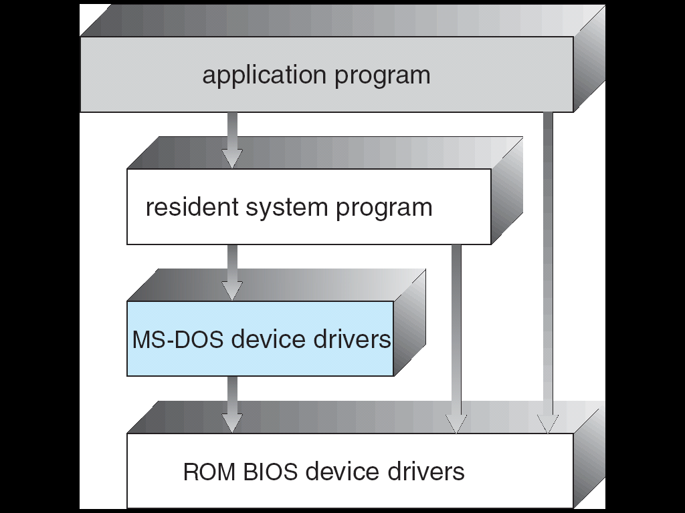**MS-DOS Layer Structure**

**Layered Approach**

* The operating system is divided into a number of layers (levels), each built on top of lower layers. The bottom layer (layer 0), is the hardware; the highest (layer N) is the user interface.
* With modularity, layers are selected such that each uses functions (operations) and services of only lower-level layers

**Traditional UNIX System Structure**

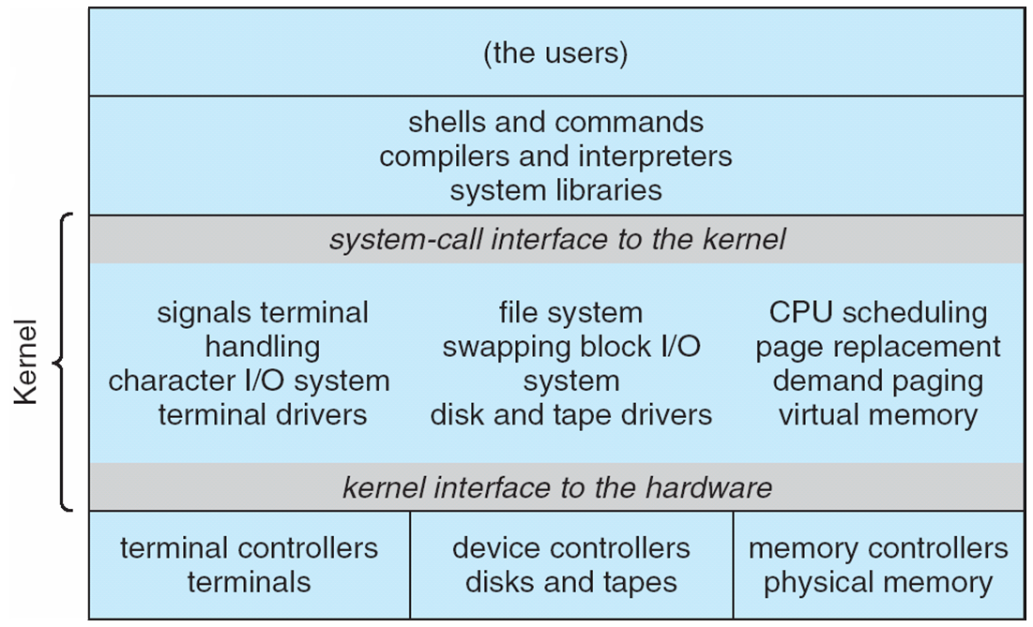

**UNIX**

* UNIX – limited by hardware functionality, the original UNIX operating system had limited structuring. The UNIX OS consists of two separable parts
* Systems programs
* The kernel

Consists of everything below the system-call interface and above the physical hardware

Provides the file system, CPU scheduling, memory management, and other operating-system functions; a large number of functions for one level

## Layered Operating System

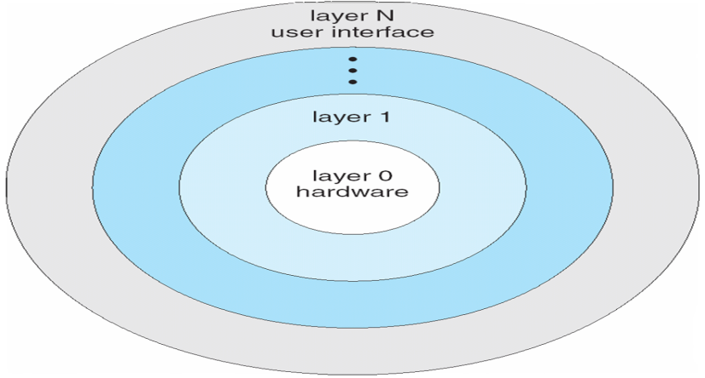

**Micro kernel System Structure**

* Moves as much from the kernel into “*user*” space
* Communication takes place between user modules using message passing
* Benefits:
* Easier to extend a microkernel
* Easier to port the operating system to new architectures
* More reliable (less code is running in kernel mode)
* More secure
* Detriments:
* Performance overhead of user space to kernel space communication

## Mac OS X Structure

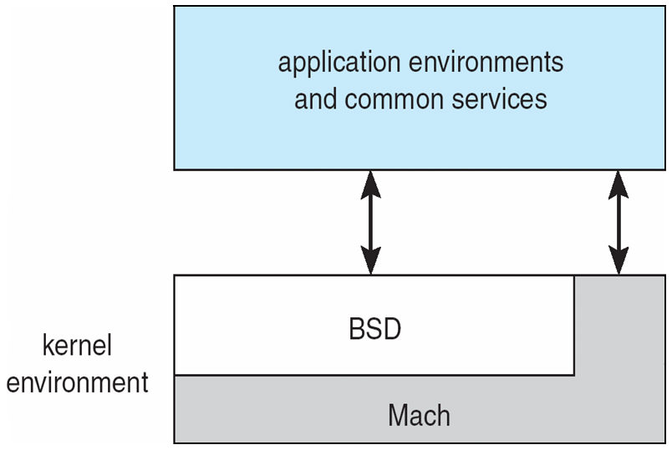

**Modules**

* Most modern operating systems implement kernel modules
* Uses object-oriented approach
* Each core component is separate
* Each talks to the others over known interfaces
* Each is loadable as needed within the kernel
* Overall, similar to layers but with more flexible

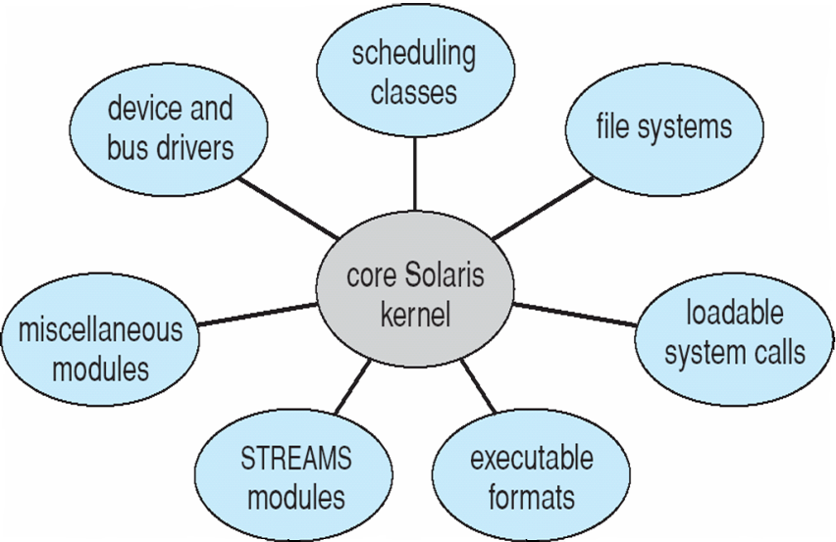

## Solaris Modular Approach

**Virtual Machines**

* A virtual machine takes the layered approach to its logical conclusion. It treats hardware and the operating system kernel as though they were all hardware
* A virtual machine provides an interface *identical* to the underlying bare hardware
* The operating system host creates the illusion that a process has its own processor and (virtual memory)
* Each guest provided with a (virtual) copy of underlying computer

**Virtual Machines History and Benefits**

* First appeared commercially in IBM mainframes in 1972
* Fundamentally, multiple execution environments (different operating systems) can share the same hardware
* Protect from each other
* Some sharing of file can be permitted, controlled
* Commutate with each other, other physical systems via networking
* Useful for development, testing
* Consolidation of many low-resource use systems onto fewer busier systems
* 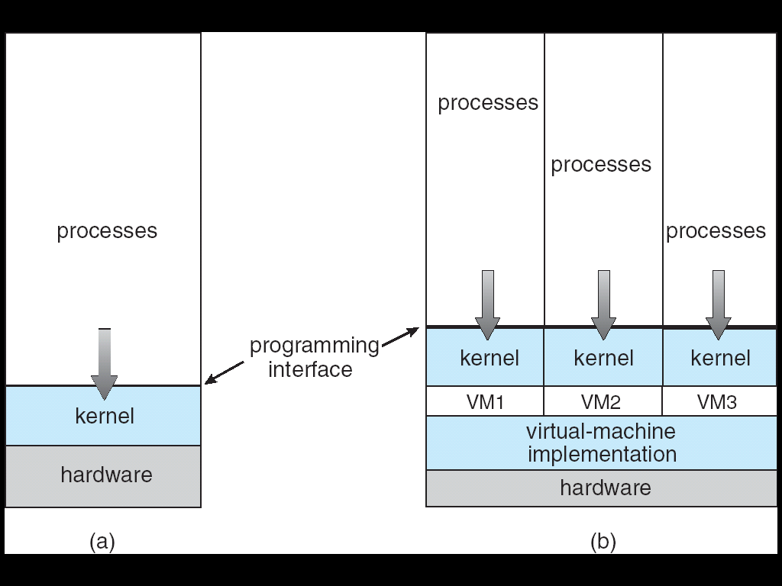“Open Virtual Machine Format”, standard format of virtual machines, allows a VM to run within many different virtual machine (host) platforms

**Para-virtualization**

* Presents guest with system similar but not identical to hardware
* Guest must be modified to run on paravirtualized hardwareF
* Guest can be an OS, or in the case of Solaris 10 applications running in containers

**Solaris 10 with Two Containers**

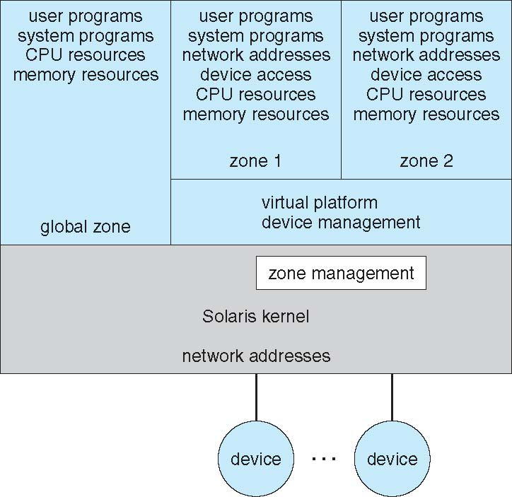

**VMware Architecture**

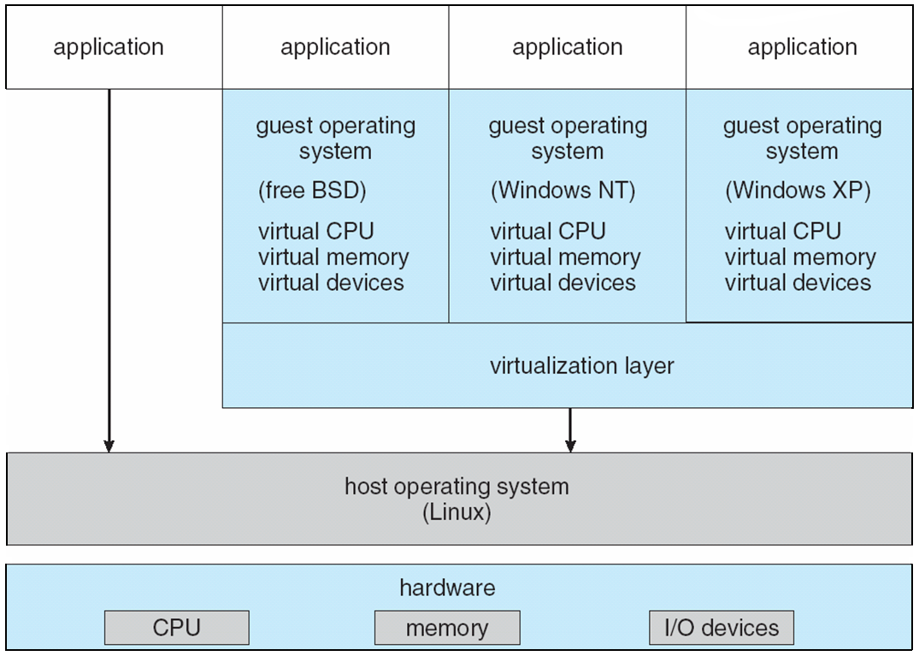

**The Java Virtual Machine**

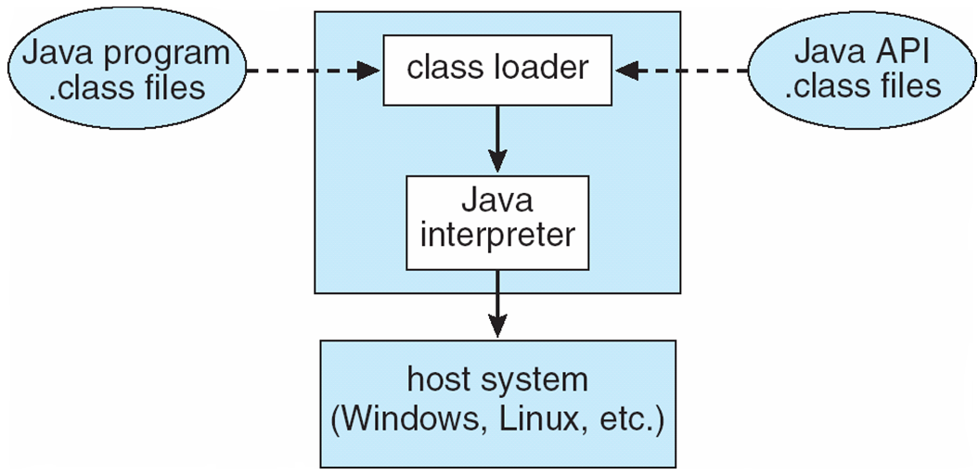

**Operating-System Debugging**

* Debugging is finding and fixing errors, or bugs
* OSes generate log files containing error information
* Failure of an application can generate core dump file capturing memory of the process
* Operating system failure can generate crash dump file containing kernel memory
* Beyond crashes, performance tuning can optimize system performance
* Kernighan’s Law: “Debugging is twice as hard as writing the code in the rst place. Therefore, if you write the code as cleverly as possible, you are, by deﬁnition, not smart enough to debug it.”
* DTrace tool in Solaris, FreeBSD, Mac OS X allows live instrumentation on production systems
* Probes fire when code is executed, capturing state data and sending it to consumers of those probes

**Solaris 10 dtrace Following System Call**

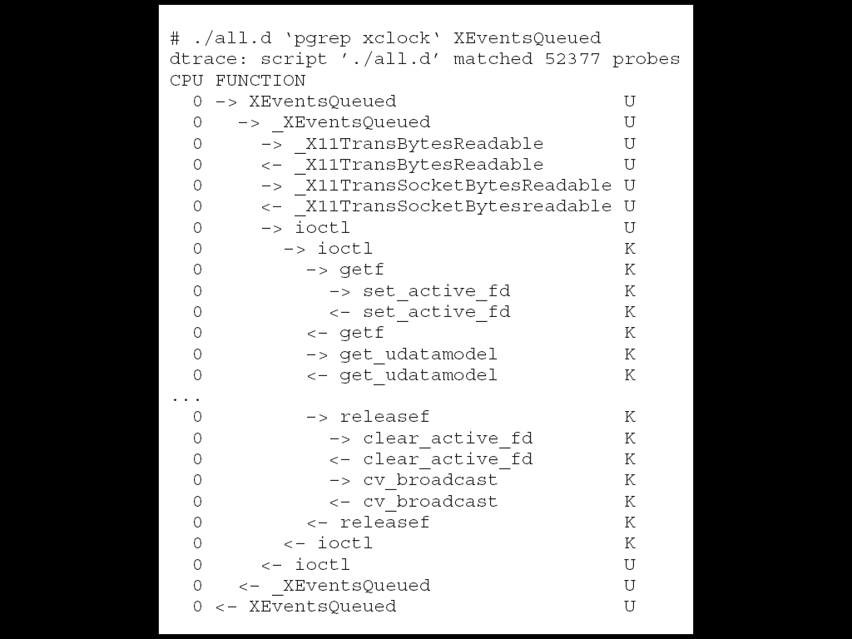

**Operating System Generation**

* Operating systems are designed to run on any of a class of machines; the system must be configured for each specific computer site
* SYSGEN program obtains information concerning the specific configuration of the hardware system
* *Booting* – starting a computer by loading the kernel
* *Bootstrap program* – code stored in ROM that is able to locate the kernel, load it into memory, and start its execution

**System Boot**

* Operating system must be made available to hardware so hardware can start it
* Small piece of code – **bootstrap loader**, locates the kernel, loads it into memory, and starts it
* Sometimes two-step process where **boot block**
* 

Firmware used to hold initial boot code